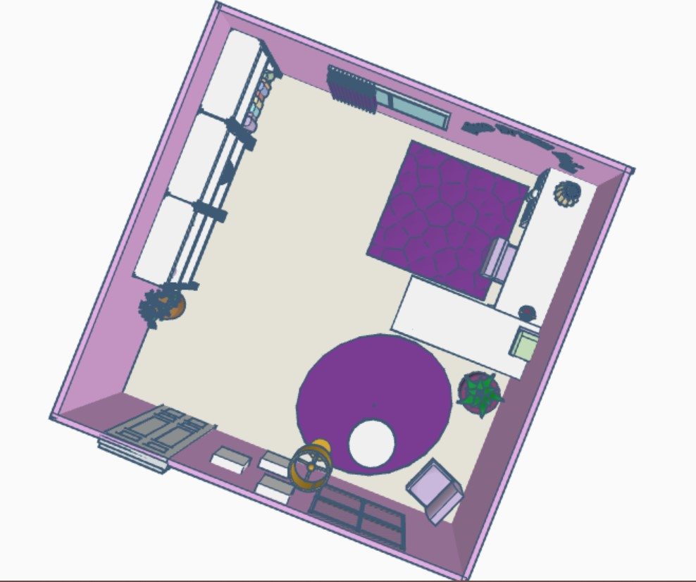

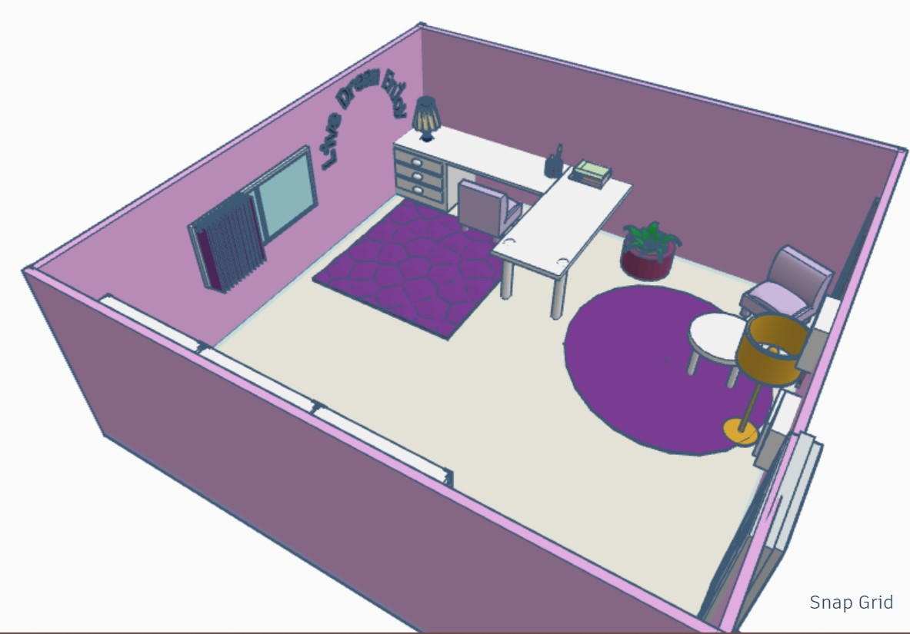

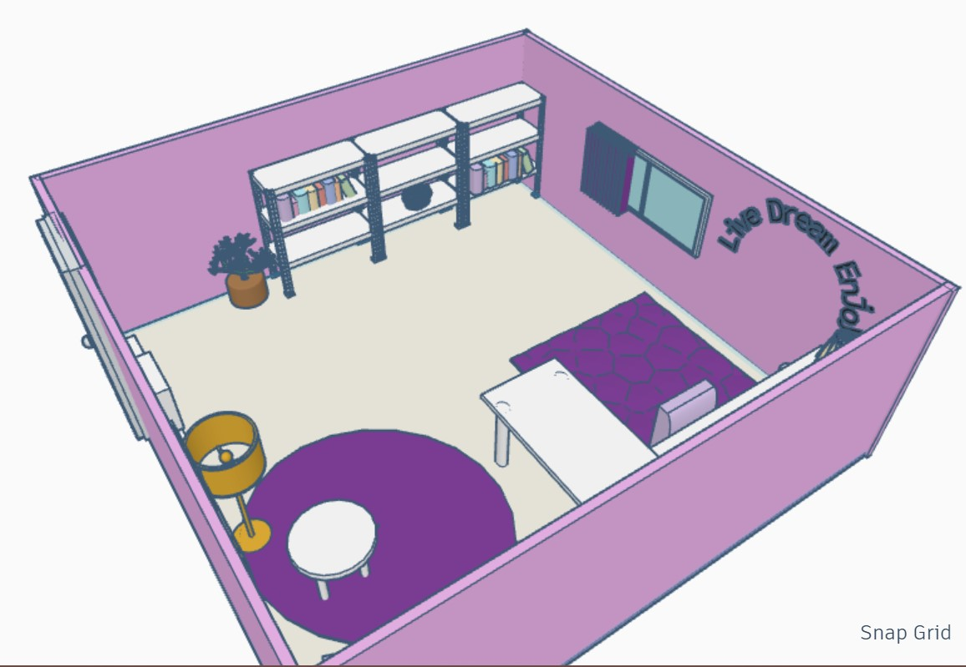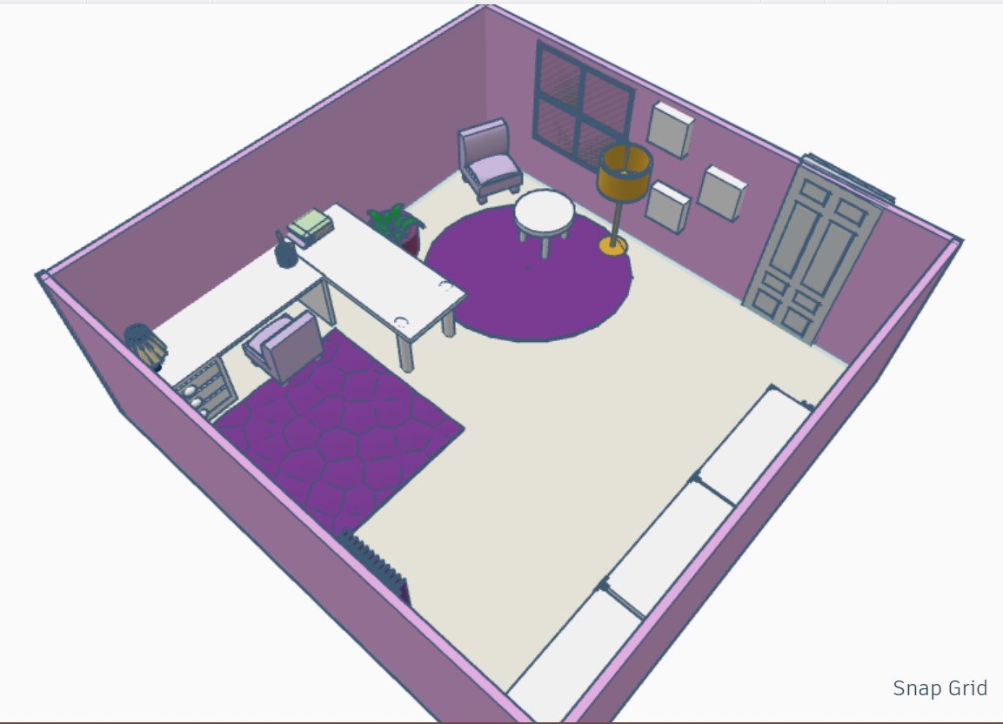

**Description:**

The aim of the activity was to create a 3-D model of study room using tinkercad.

Basic furniture pieces such as study tables, chair, side table and shelves has been used to create a layout of the room. The study table is joined with another table to give ample space for studying, monitors and storage. On top of the desk is a pencil holder and a lamp for improved lighting. The room also has sufficient shelves for storage such as books or any other decorative items.

In the one of the corners of the room, a sitting nook is attempted near the window, with a chair to sit, hanging box shelves for storage and a small side table to hold any items. The nook is to provide for a different environment other than the study area.

Windows are added on two of the walls for ventilation, while curtains and door has been added for privacy.

This room is decorated throughout using lavender colour, plants, carpets, vases, lamps and some inspiring text on the walls to give an inspirational ambiance and a personalized touch.